Questions - Test 14th March 2007

- What are the differences between Oceanic and Continental crust?
- What are the principle pathways of marine sediments to the Deep Sea?
- What is a turbidity current and how do they form?
- Explain the concept of paleomagnetism.
- Describe the processes affecting the distribution of samples A, B and C

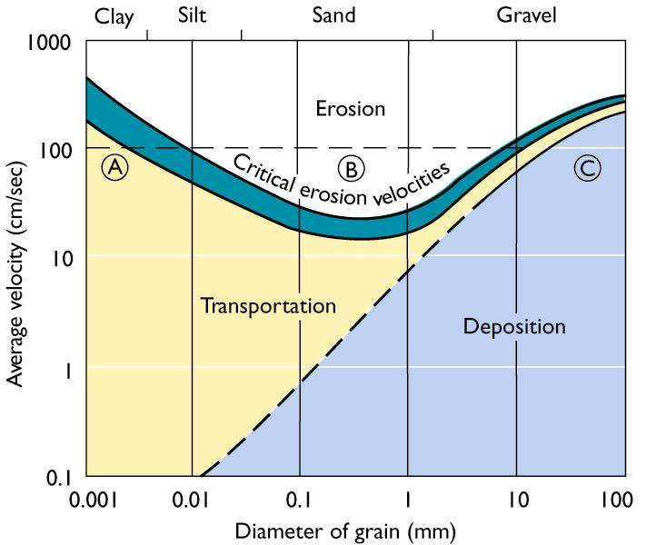

- Define sensible heat and latent heat.
- What is an ADCP and how does it work?
- Explain the processes that affect salinity in the oceans.
- What is a thermocline and how does its structure vary seasonally?
- How does the pycnocline affect dissolved oxygen concentrations?
- Explain why light varies between coastal and deep ocean regions.
- What are the most abundant ions in seawater.

